Massage/Bodywork Intake Form
Facility: Gap Wellness: 1120 E. Elizabeth St. Suite G2, Fort Collins, CO 80524, 970-223-7425
Massage Therapist: Jessica Kraus, LMT (CO License #0009325)
Phone: (970) 223-7425
Date: ____________________
Hello, my name is Jessica Kraus, I have over 20 years' experience in massage therapy and the health & wellness industry and more than 18 years working alongside a family of naturopathic doctors with over 100 years of combined knowledge. I have collaborated with dozens of alternative healthcare providers to meet patient needs. My training includes decades of continuing education and hands-on experience in various modalities and treatments. I graduated from massage school in 2005 with honors and continued expanding my training from there by completing Reflexology Certification, Holistic Health Practitioner Certification, and obtained National Board Certification in Health & Wellness Coaching. My specialty is deep tissue and trigger point therapy as well as integrative massage. I’m able to intuitively palpate the body’s own signals which allow me to adjust the sessions to individual needs. My techniques are therapeutic in nature. I offer additional services including red light therapy, aromatherapy, constitutional hydrotherapy, and warm packs. Feel free to request any of these services that you feel would make your time with me more valuable to you. Reflexology on the hands, feet, and ears are also available services that can be added to your massage or scheduled at your convenience.
Patient Information:
Name: ____________________________________________ DOB: ____________________
Address: __________________________________________ Phone: ____________________
Email: ____________________ Occupation: _______________________________________
Emergency Contact: ____________________ Phone: ____________________
How did you hear about us? ________________________________________________________________________________
Massage History: Have you received professional massage therapy before? Yes / No If yes, how often? _____________________________________________________ Preferred pressure: Light / Medium / Deep
What type of massage are you seeking today? (e.g., relaxation, therapeutic, sports) _________________________________________________________________________________________________
Reason for Visit: Please describe your main concerns or goals for this session: ________________________________________________________________________________
On a scale of 0-10 (0=no pain, 10=worst pain), rate your current pain level: ______
Areas of pain/tension:___________________________________________________________________________
Body Diagram: Please mark areas of concern on the diagram below with an "X" for pain, "T" for tension, or other notes. (Front and Back views)
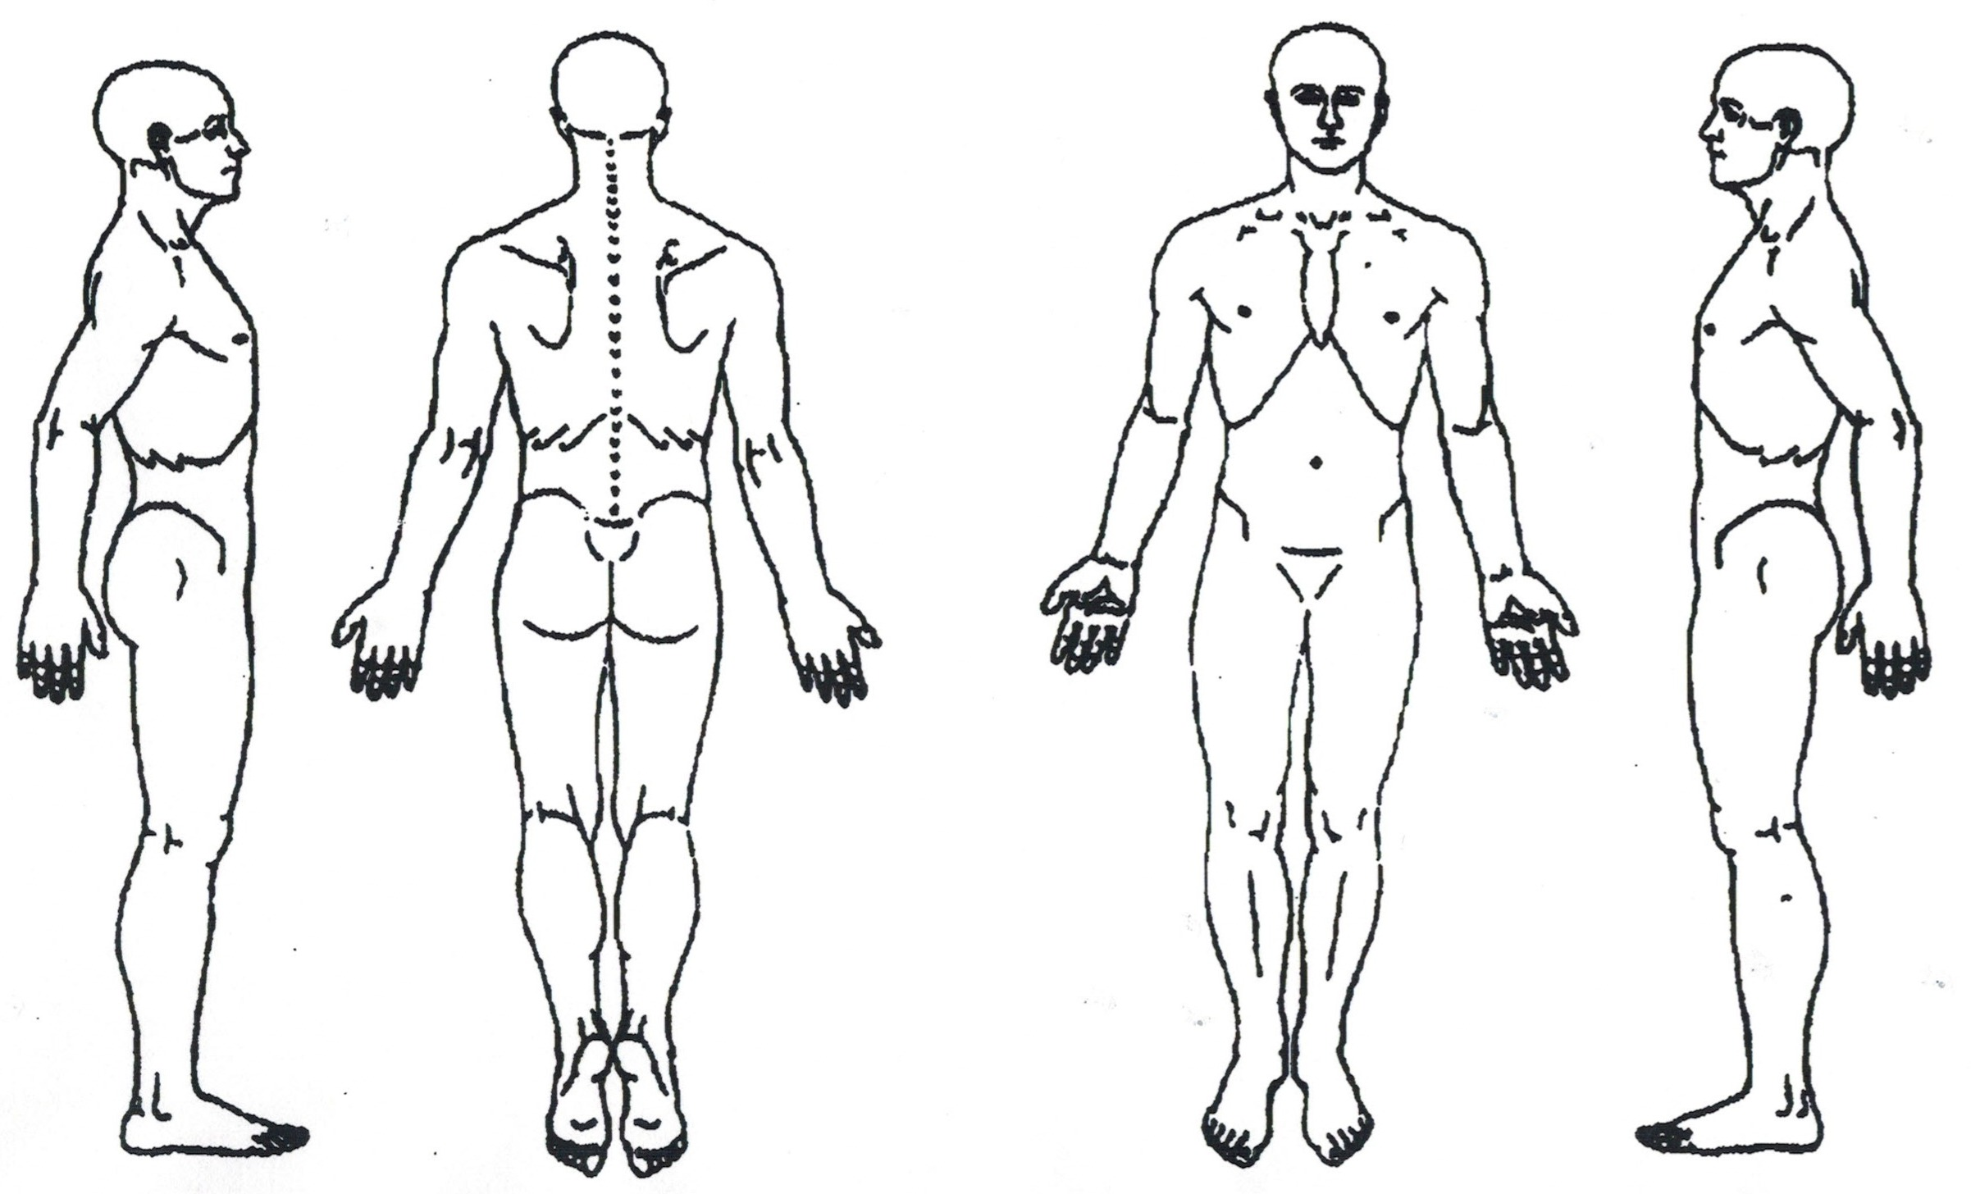Notes on marked areas: ________________________________________________________________________________
Medical History: (Check all that apply and provide details/dates)
- Heart conditions (e.g., high blood pressure, pacemaker) ______________________________________
- Circulatory issues (e.g., blood clots, varicose veins) __________________________________________
- Respiratory conditions (e.g., asthma, COPD) _________________________________________________
- Lymphatic System (swollen lymph nodes, surgeries) __________________________________________
- Diabetes ________________________________________________________________________________
- Neurological issues (e.g., epilepsy, migraines) _______________________________________________
- Musculoskeletal (e.g., arthritis, osteoporosis, recent injuries/fractures) ________________________
- Skin conditions (e.g., eczema, open wounds, rashes) _________________________________________
- Cancer (type/stage/treatment) _____________________________________________________________
- Surgeries (type/date) ______________________________________________________________________
- Chronic pain conditions (e.g., fibromyalgia) _________________________________________________
- Pregnancy (current/due date) _______________________________________________________________
- Allergies (e.g., to oils, nuts, latex) ___________________________________________________________
- Do you wear contact lenses? Yes / No_______________________________________________________
- Recent illness or fever? Yes / No (details) ____________________________________________________
- Any contagious conditions? Yes / No (details) ________________________________________________
- Medications/Supplements ________________________________________________________________________________
________________________________________________________________________________
________________________________________________________________________________
Vaccinations Received: (List vaccinations and approximate dates received)
- COVID-19 (including boosters) ____________________
- Influenza (Flu) ____________________
- Tetanus/Diphtheria/Pertussis (Tdap) ____________________
- Measles/Mumps/Rubella (MMR) ____________________
- Hepatitis A/B ____________________
- Pneumococcal ____________________
- Shingles ____________________
- Other: ________________________________________________________________________________
Lifestyle: Please provide details about your daily routine and habits to help tailor your massage and allows me to accommodate your needs better:
- Work/Occupation Description: __________________________________________________________________________________________
- Stress Level: Low / Medium / High (describe sources of stress) __________________________________________________________________________________________
- Physical Activities/Exercise: ( frequency, type) __________________________________________________________________________________________
- Sleep Patterns: (e.g., hours per night, quality: Good / Fair / Poor; issues) __________________________________________________________________________________________
- Diet and Nutrition: (e.g., typical meals, hydration levels, any dietary restrictions or supplements) __________________________________________________________________________________________
- Daily Habits: (e.g. work/activities, screen time, self-care, hobbies, stress management) _________________________________________________________________________________________
- Spirit and Soul Health: (practices or routines you participate in) (prayer and/or mindfulness) (sense of purpose, emotional well-being) (connection to self/others/nature/higher power/God) any known spiritual or soul wounds) ________________________________________________________________________________________
________________________________________________________________________________________
- Any recent accidents, falls, or injuries? Yes / No (details, including date and recovery status) ________________________________________________________________________________________
- Other lifestyle factors: (e.g., travel frequency, environmental exposures, overall energy levels) _________________________________________________________________________________________

HIPAA Privacy Notice Acknowledgment: I acknowledge that I have received a Notice of Privacy Practices, which explains how my protected health information (PHI) may be used and disclosed in accordance with the Health Insurance Portability and Accountability Act (HIPAA). I understand my rights regarding my PHI, including the right to access, amend, and request restrictions on its use. Gap Wellness, Intentional Integration, and staff is committed to protecting my privacy and will only use or disclose my PHI as permitted by law, such as for treatment, payment, healthcare operations, or with my authorization. For questions, contact our office at (970) 223-7425.
Signature for HIPAA Acknowledgment: ___________________________________Date: ____________________
Consent and Acknowledgment: I certify that the information provided is accurate and complete. I understand massage therapy is for relaxation and wellness, not a substitute for medical treatment. I consent to massage therapy by Jessica Kraus, LMT, and agree to communicate any discomfort. I release Gap Wellness, Intentional Integration, and staff from liability except for negligence, per Colorado law. I authorize contact with my primary doctor if needed.
Patient Signature: ________________________________________ Date: ____________________

